Day 5 Exploratory Data Analysis & Visualization Report

Overview
Performed Exploratory Data Analysis (EDA) on the Titanic dataset using Pandas, Matplotlib, and Seaborn. The analysis focused on descriptive statistics, distributions, categorical comparisons, relationships between variables, outlier detection, and correlation analysis.

1. Descriptive Statistics
Calculated descriptive statistics for the Age column, including:
- Mean
- Median
- Mode
- Standard deviation
- Minimum and maximum
- 25th, 50th, and 75th percentiles

Results
- Mean Age: 29.64
- Median Age: 28
- Mode Age: 24
- Standard Deviation: 14.49
- Minimum Age: 0.42
- Maximum Age: 80
- 25th Percentile: 20
- 50th Percentile: 28
- 75th Percentile: 38
The results show that most passengers were relatively young, with the middle 50% of ages falling between 20 and 38.

2. Age Distribution
Created a histogram of the Age column using Matplotlib with 20 bins.
The histogram was used to observe how passenger ages were distributed across different age ranges.
Visualization:
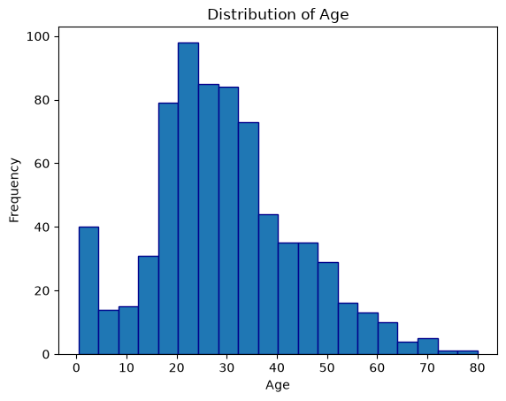

3. Survival Rate by Sex
Grouped passengers by Sex and calculated the average of the binary Survived column to determine the survival rate.

Results
- Female: 74.04%
- Male: 18.89%
Female passengers had a substantially higher survival rate than male passengers.
A bar chart was created to visually compare the survival rates.
Visualization:
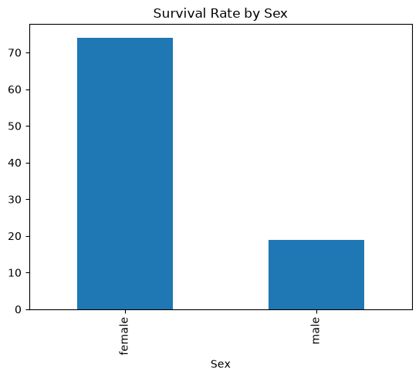

4. Survival Rate by Passenger Class
Grouped passengers by Pclass and calculated survival rates.

Results
- 1st Class: 62.62%
- 2nd Class: 47.28%
- 3rd Class: 24.24%
The results show that survival rates decreased as passenger class decreased, with 1st-class passengers having the highest survival rate and 3rd-class passengers having the lowest.
A bar chart was created to visualize the comparison.
Visualization:
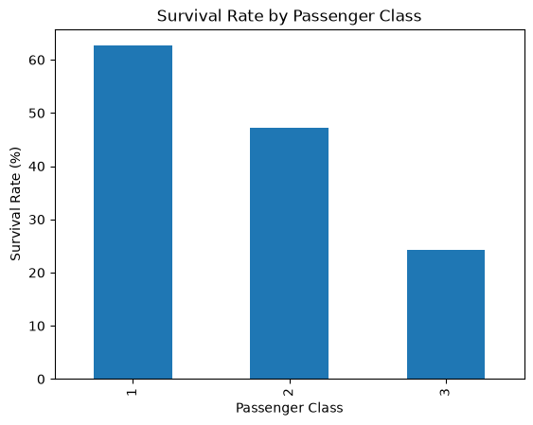

5. Age and Fare Relationship
Created a scatter plot comparing Age and Fare.
The correlation between the two variables was also calculated:
Correlation: 0.093
This indicates a very weak positive linear relationship between passenger age and fare. In this dataset, age and fare therefore had little linear relationship.
Visualization:
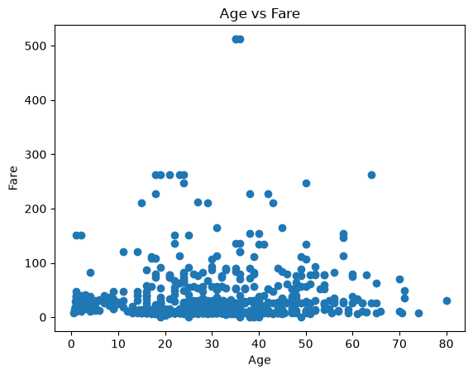

6. Fare Distribution and Outliers
Created a box plot for the Fare column to examine its distribution and identify potential outliers.
The box plot showed that most fares were concentrated at lower values, while some passengers had considerably higher fares. These higher values can represent potential outliers but were not removed because they may represent legitimate ticket prices.
Visualization:
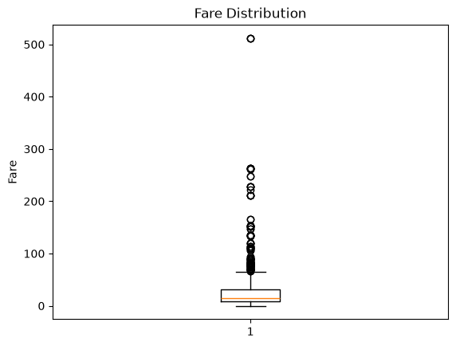

7. Correlation Analysis
Created a correlation matrix for the numeric columns using Pandas and visualized it with a Seaborn heatmap.
The heatmap was used to identify positive and negative relationships between numeric variables. Values close to 1 indicate a strong positive relationship, values close to -1 indicate a strong negative relationship, and values close to 0 indicate a weak or negligible linear relationship.
The diagonal values of 1 represent each variable's perfect correlation with itself.
Visualization:
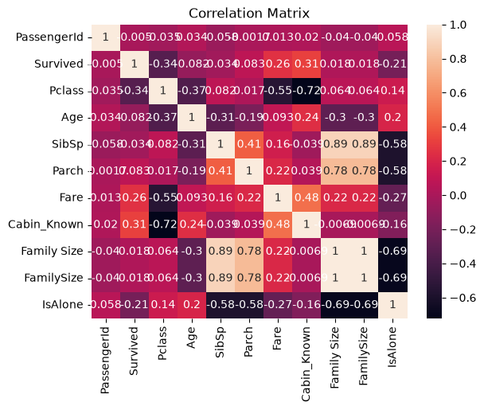

Business Insights
• Survival by sex: Female passengers had a 74.04% survival rate, compared with 18.89% for male passengers.
• Survival by class: First-class passengers had a 62.62% survival rate, compared with 47.28% in second class and 24.24% in third class.
• Age distribution: The median passenger age was 28, and the middle 50% of ages ranged from 20 to 38.
• Age and fare: The correlation was approximately 0.093, indicating a very weak positive linear relationship.
• Fare outliers: The box plot indicated potential high-fare outliers that may represent legitimate ticket prices.

Tools Used
- Python
- Pandas
- Matplotlib
- Seaborn

Conclusion
The EDA provided several useful observations from the Titanic dataset. Passenger age was distributed mainly around younger and middle-aged groups. Survival rates differed substantially by sex and passenger class, with females and 1st-class passengers having higher survival rates. Age and fare showed very little linear correlation, while the fare box plot highlighted several high-value fares that could be potential outliers. The correlation heatmap provided an overall view of relationships between the dataset's numeric variables.

